2022 Dark Sky Event Calendar – Rappahannock County Park

RCRFA will open the park a total of nine (9) evenings during 2022 during which the public can come and observe the night skies (nominally once a month during the warmer months). These are listed below.
NOTE: RLEP will provide a Dark Sky Event/ Program on 4 of the scheduled viewing evenings.
Change to Daylight Savings Time: Sun. March 13. Change to Standard Time: Sun. Nov. 6
New Moon: Mar 31
- Free Observation Evening: Sat. Apr. 2 (Sunset 7:35 pm - thin moon crescent)
New Moon: Apr 30
- Dark Sky Event: Sat. Apr. 30, 8:00 pm – (Sunset 8:00 pm - no moon)
Full Moon: May 15
- Free Observation Evening: Sat. May 21 (Sunset 8:15 pm – last quarter)
Full Moon: June 14
- Dark Sky Event: Sat. June 11, 8:30 pm – (Sunset 8:32 pm – near full moon)
New Moon: July 28
- Free Observation Evening: Sat. July 30, (Sunset 8:22 pm - thin moon crescent)
New Moon: Aug. 27
- Dark Sky Event: Sat. Aug. 27, 7:45 pm – (Sunset 7:51 pm - no moon)
Full Moon: Sept 10
- Free Observation Evening: Sept 17 (Sunset 7:14 last quarter)
New Moon: Sept. 25
- Dark Sky Event: Sat. Sept. 24, 7:00 pm – (Sunset 7:06 pm - no moon)
New Moon: Oct. 25
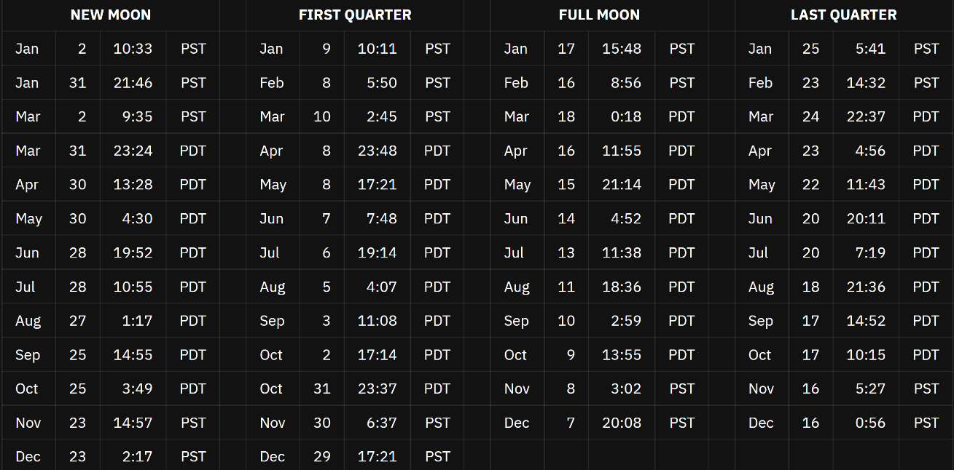
- Free Observation Evening: Sat. Oct. 22, (Sunset 6:26 pm - no moon)

